## Video Consultations Grosvenor Road Surgery

How to set up and use Zoom

1. You will receive a text message from the surgery with a link to the video consultation, click the link.

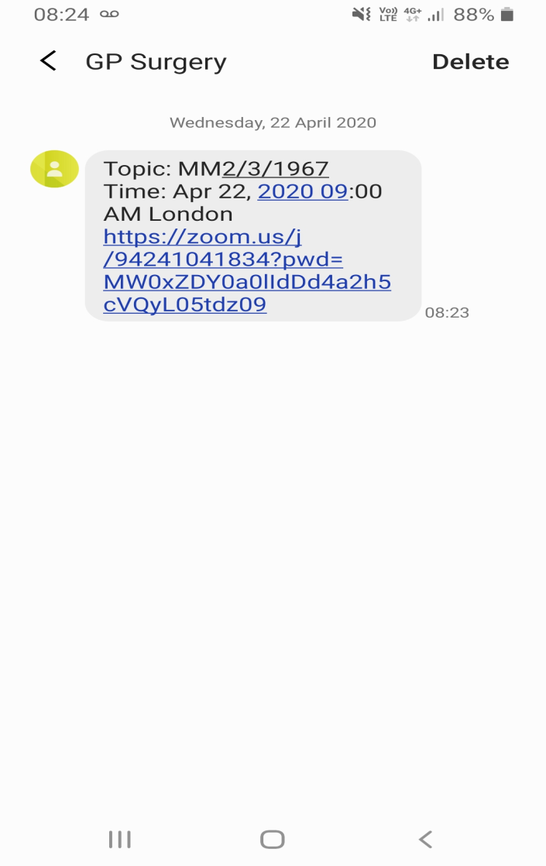

1. This will bring you to the zoom page. Click on the download button.

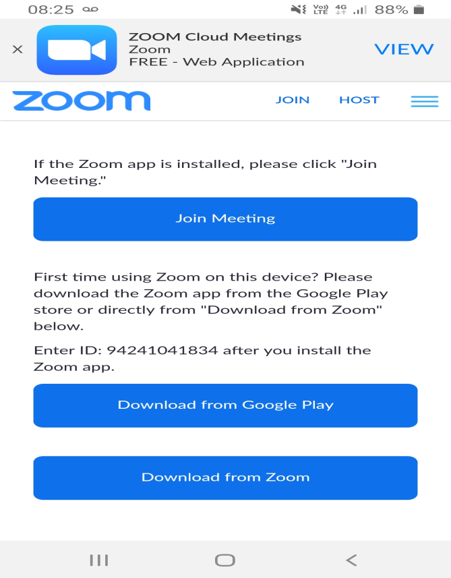

1. Click install



1. When installed click open

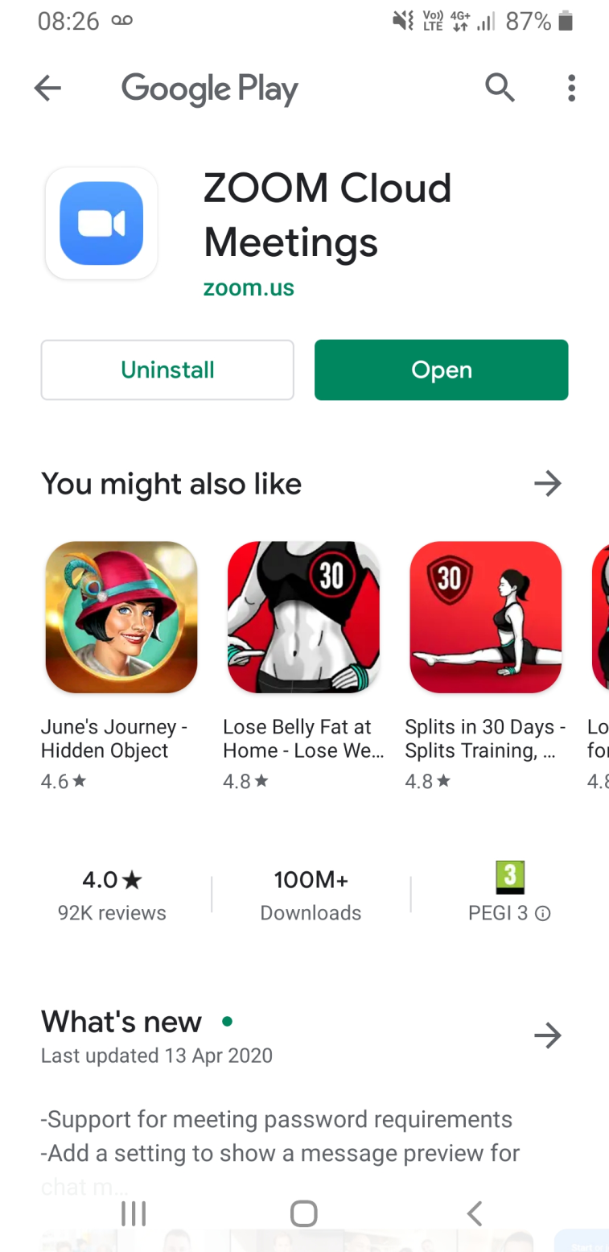

1. Go back to the text message and click the link again and open with zoom. This will open the video consultation.

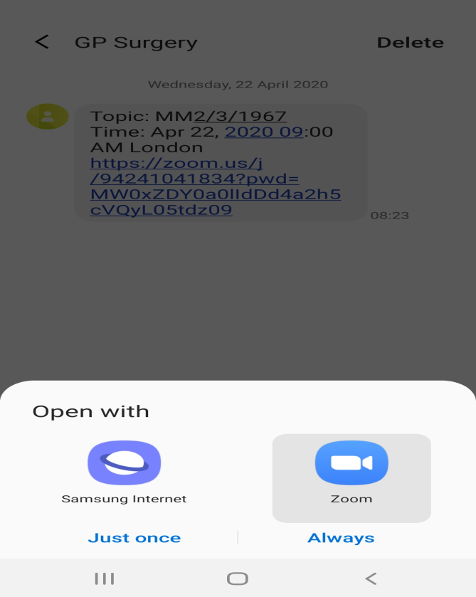

1. Enter your name

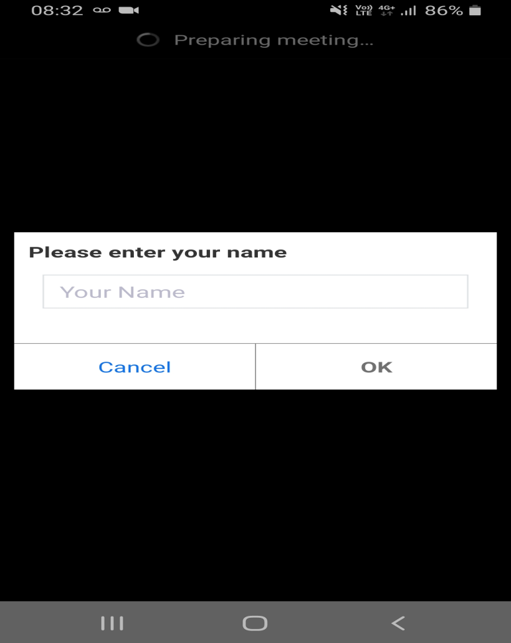

1. Agree with terms and conditions

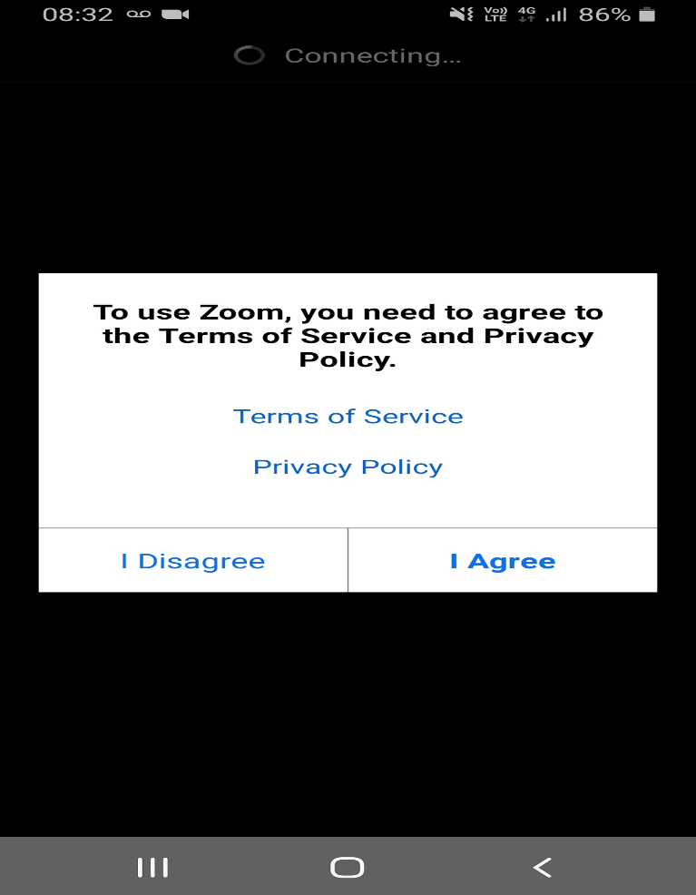

1. You will then be sent to ‘the waiting room’ and the doctor will start the consultation

